Ideation Phase
Brainstorm & Idea Prioritization Template

Date | 31 January 2026
Team ID | LTVIP2026TMIDS28502
Project Name | Visualizing Housing Market Trends: An Analysis of Sale Prices and Features using Tableau
Maximum Marks | 4 Marks

Brainstorm & Idea Prioritization Template:
As we brainstormed ideas for the Housing Market Visualization project, our team actively participated in discussing various approaches for analysing and presenting housing data using Tableau. Each team member contributed ideas related to data visualization techniques, dashboard design, and analytical methods. Similar ideas were grouped together to identify key analytical objectives and ensure a structured approach toward solving the problem. Once all ideas were shared, we organized the concepts into meaningful categories based on their analytical and functional relevance. Each group was assigned a clear label to represent its focus area—such as Data Preparation, Visualization Development, Dashboard Design, and Insight Generation. This structured brainstorming process provided clarity on the project’s main analytical components and helped the team effectively prioritize tasks, ensuring a systematic transition into project planning, dashboard creation, and implementation phases.
Link: https://app.mural.co/t/visualizinghousemarkettrends6575/m/visualizinghousemarkettrends6575/1771311142317/e24654dd587edfdf90c921403e536b44df1ae60d?sender=u47c9bca3661e3dc3996a2844
Reference: https://www.mural.co/templates/brainstorm-and-idea-prioritization
Step-1: Team Gathering, Collaboration and Select the Problem Statement
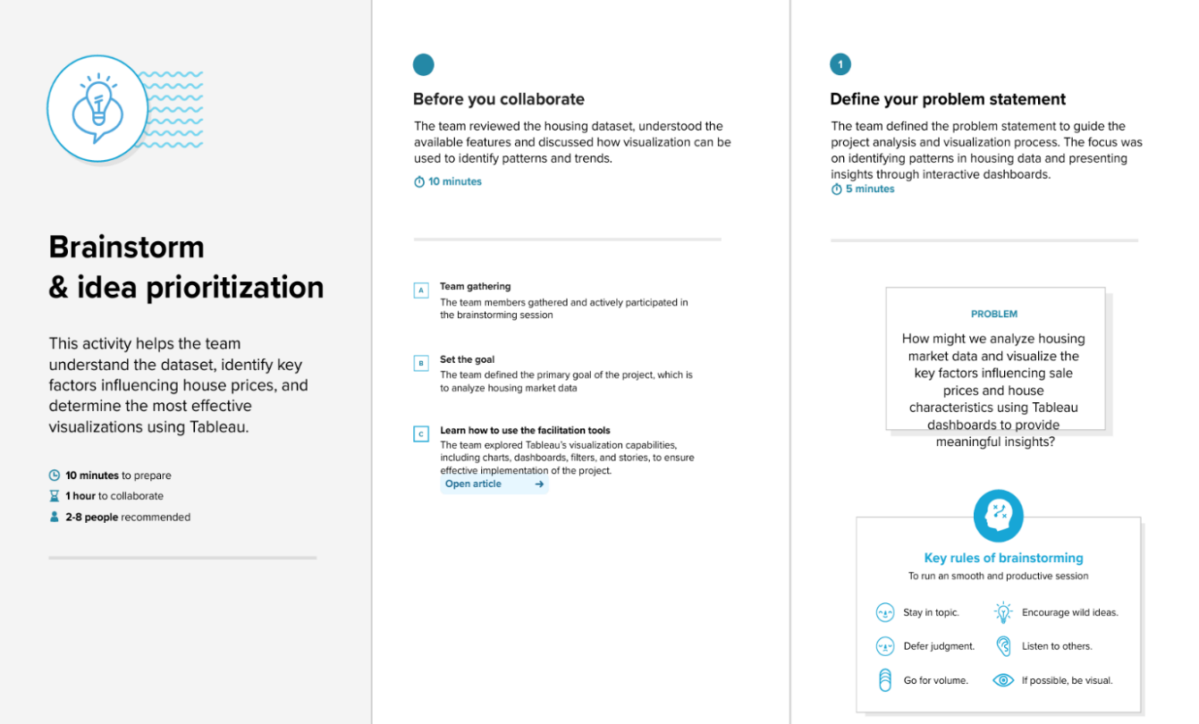

Step-2: Brainstorm, Idea Listing and Grouping
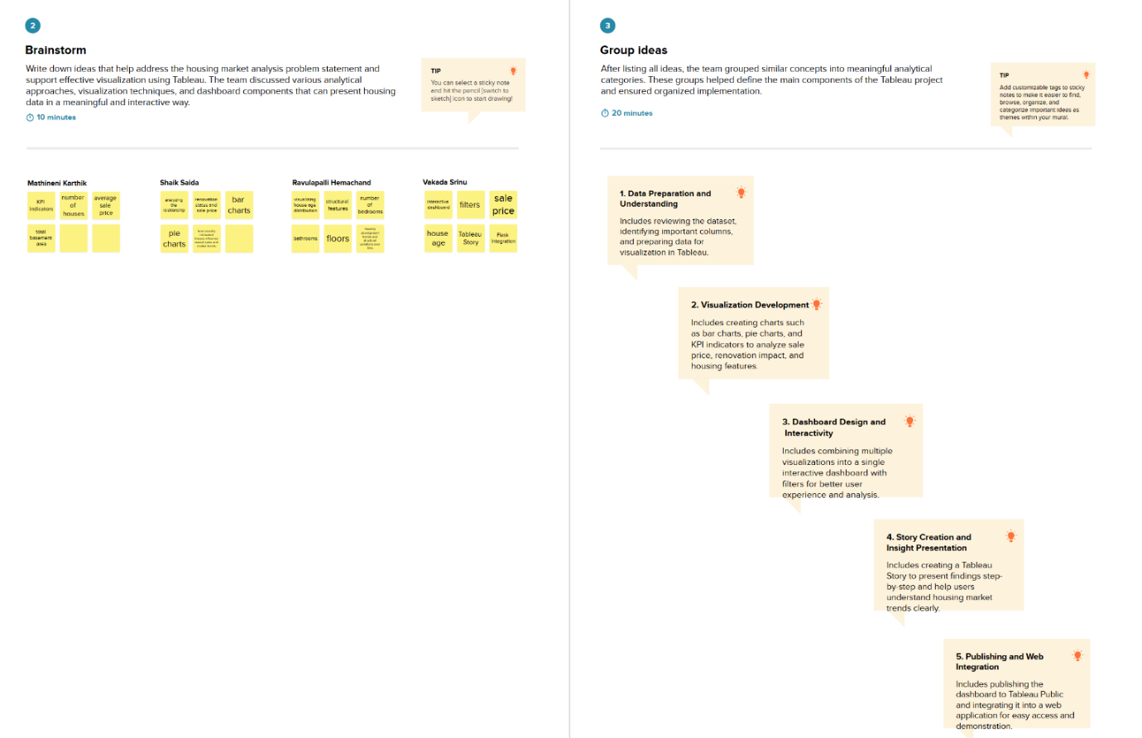
Step-3: Idea Prioritization
